Chillagoe Caving Club
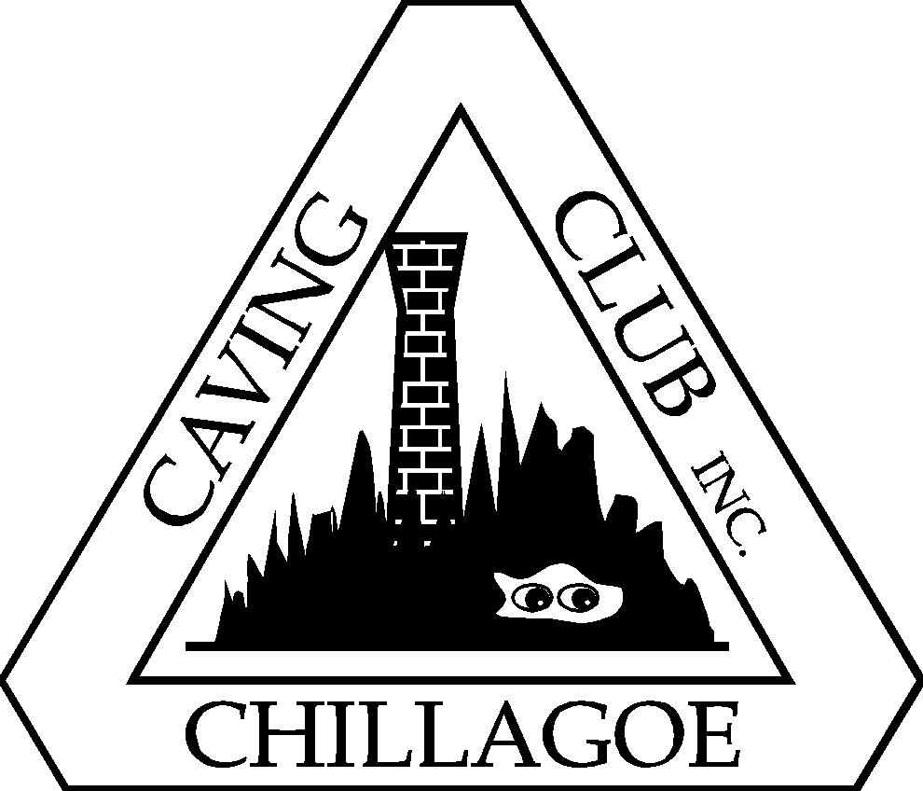

Trip Leader Training Scheme (May 2017)

Philosophy
The philosophy behind the Club’s training and assessing of Trip Leaders is that it is done in the real environment. We do not intend to run Trip Leader courses, have examinations or test people in theoretical or mocked up situations. Prospective Trip Leaders will be accompanied by experienced Trip Leaders on a number of caving trips in which their performance as Trip Leader will be evaluated while in control of a caving party with a number of Novices or Guests.

The accompanying experienced Trip Leaders will educate, advise and evaluate the prospective Trip Leader in the various aspects of the job until the necessary standard is achieved. The other members of the party will also gain knowledge that will assist them later in achieving Trip Leader qualification.

When two experienced Trip Leaders are confident that the prospective Trip Leader has the necessary attitudes, skills and experience they will recommend certification as a Trip Leader.

An Assessor, other than one of the above, will make an appropriate recommendation to the Management Committee after making his own assessment on the prospective Trip Leader.

The Management Committee will ratify the recommendation and make the appointment.

If any Members are dissatisfied with the decision of the Management Committee they can appeal as set out in Clause 11 of the Constitution

Ethics
The Club Constitution requires Members to abide by the ASF Codes of Ethics and the Code of Minimum Impact Caving, so these must be clearly established in training and evaluation of Members as prospective Trip Leaders.

Requirements for Certification of Trip Leader
The Club has adopted two levels of Trip Leader. These are Trip Leader (no SRT) and Trip Leader (with SRT). Consideration needs to be given to an additional certificate covering Cave Rescue Leader in due course.

During the training and assessment of the proficiency of a prospective Trip Leader the following aspects of the job will be included:

(i) Trip Leader (no SRT)

Ethics
Ensures that the standards of the ASF Code of Ethics are known and followed during the trip

Minimal Impact Caving
Ensures the standards and practices of the ASF Code of Minimal Impact Caving are known and used by the party

Safety
Ensures safety standards are maintained

Preliminary
Selects cave suitable for party
Selects suitable equipment for cave
Instructs party adequately prior to entering cave

Group Matters
Ensures compliance of party with good caving practices
Aids communication in caving party
Maintains a high level of awareness of needs of party
Ensures welfare of party
Maintains a positive social environment during trip

Leadership
Demonstrates his ability to lead the party during the trip

Techniques
Establishes and follows safe procedures
Ensures that equipment is used correctly
Uses belays correctly and when necessary, with correct use of calls
Ensures correct and safe use of caving ladders
Teaches and ensures safe free climbing techniques

Emergencies
Evaluates the situation
Develops a suitable plan
Controls the emergency

Reports
Completes all necessary reports for the trip

(ii) Trip Leader (with SRT)
Before undertaking this qualification a Trip Leader (no SRT) qualification must be held.

Has basic understanding of SRT techniques

Shows practical skill in selecting and using SRT equipment

Safety
Observes all safety procedures

Rigging
Rigs and de-rigs pitches safely
Understands how to deal with unusual situations in vertical caving
Rigs safely for complex non-routine situations
Rigs and negotiates re-belays and re-directions safely
Demonstrates changeovers

Pitches
Has acquired advanced free climbing techniques
Can descend and ascend pitches of any height

Rescue
Has basic understanding of SRT rescue techniques

Paper Trail
In view of any possible legal consequences, should an accident occur, it is necessary to establish a paper record that Trip Leaders have been examined and reached adequate standards of proficiency in the requirements of the job. To achieve this we have produced the attached forms for Application for Trip Leader Certificate for each level.

These forms include an application by the candidate; certification by two other qualified Trip Leaders that they have examined the Prospective Trip Leader in all aspects of the job; and satisfied themselves that an adequate standard has been met. A qualified Assessor, who also satisfies him/herself that the candidate has reached an adequate standard, then certifies the form. The Management Committee after considering the application ratifies the appointment and issues a numbered Certificate for the appointment. Should the Management Committee decline to ratify any appointment the applicant has the option of appeal against the decision in accordance with Clause 11 of the Constitution.

The Management Committee shall keep all applications and a permanent register of Certificates issued in each category.

Withdrawal of Trip Leader Certificate
The Management Committee may at any time withdraw the appointment of Trip Leader if they consider that the person concerned no longer meets the requirements. The Trip Leader has the option of appeal against the decision in accordance with Clause 11 of the Constitution.

Trip Leaders and Assessors appointed by Peer Assessment
While this arrangement was necessary to initialise the Trip Leader Scheme it is desirable to set up the same paper trail for these appointments. The forms should be completed for these Members and new numbered Certificates issued to establish the same legal certainty as applies to new applicants who go through the certification process.

Caving Skill – Trip Leader
Application and training
Applicant to complete TL application form available on CCC website
Applicant to hold current first aid certificate
Trade route with existing Trip Leader direct supervision..
May include belays and ladder.
Non-exhaustive task checklist to be used on all caving trips and Trip Leader assessments
- Group and cave is selected
- Communicate appropriate information on trip objective, gear required and like hazards to group.
- Trip info is on the clubhouse board
- Appoint call-out person and procedure
- Communicate to group ethics of caving to any new cavers
- Have appropriate gear for cave selected
- Navigate to a cave and demonstrate movement safely and efficiently through the cave
- Identify hazards commonly present and show strategies for dealing with them considering the skills of the group.
- Be able to identify fragile areas and show techniques for negotiating them.
- Manage the group for an enjoyable caving experience taking into consideration the skills of the group.
- Navigate back to the car, return to the clubhouse, report to call-out person and remove trip info from the Board, fill in trip book details.
Trip leader L1 Horizontal
Known Cave Trade Route No SRT : No ladder, no safety belay required.
It is envisaged that level two will give a club member a level of certification as a trip leader to satisfy NP and ASF. It is aimed at a known basic cave such as Carpentaria, Macropedes, Surprise Packet, Spring. Assessed on above task checklist by trainer assessor as competent on specific cave routes. Level one trip leader gets assessed on each different cave route they wish to apply for.
- Application
- Recommended to Club Management Committee by L4 Trainer/Assessor and 2 Trip leadders
- Approved by Club Management Committee for base L1 certification, specific cave endorsements approved by L4 Assessor and recorded in Trip Leaders Log.

Trip Leader L2 - Ladder and Belay, No SRT– Non SRT Any Cave, ladder and belay.

- Application
- Be assessed as competent in L1 skills plus
- Show sound knowledge of when ladders or safety belay is required depending on the group skill set
- Demonstrate sound knowledge of rigging for and use of ladders
- Demonstrate a sound knowledge of safety belaying techniques
- Be assessed by a L4 Assessor on three trade route caves requiring the use of ladders and belays.
- Recommended to Club Management Committee by L4 Trainer/Assessor
- Approved by Club Management Committee
Trip leader L3 - Any Cave SRT

- Application
- Level one, two, and three skills plus level 5 SRT as per SRT guide
Trip leader L4 – Trainer/Assessor - for designated levels of trip leader 1, 2 or 3

Requirements
- Application
- Current Trip leader
- Be assessed by 2 Trainer/Assessors as competent in becoming a Trainer/Assessor in the level applied for.
- Recommended to Club Management Committee
- Approved by Club Management Committee

Revalidation
- For SRT Trip Leaders, the SRT component of the Trip Leader certification will expire after two years should the member not apply for re-validation and have participated in SRT training with the Club on at least two occasions during that period unless an alternative arrangement is agreed with the Management Committee. Re-validation/approval by a CCC SRT Assessor will be necessary to re-validate.
- For ALL Trip Leaders whose membership lapses for a period of six months or more, the trip leader certification will lapse and re-application for the certification will be necessary prior to acting as Trip Leader for the Club.

CHILLAGOE CAVING CLUB INC.

APPLICATION FOR TRIP LEADER Level 1 / 2 (NO SRT) CERTIFICATE

Applicant __________________________________

We have independently examined the above applicant and certify that s/he has reached an adequate standard of proficiency in the following aspects of a Trip Leader Level 1 or 2 (no SRT) duties and skills and recommend him/her for issue of a Certificate of Proficiency in the position.

Ethics
Ensures that the standards of the ASF Code of Ethics are known and followed during the trip

Minimal Impact Caving
Ensures the standards and practices of the ASF Code of Minimal Impact Caving are known and used by the party

Safety
Ensures safety standards are maintained

Preliminary
Selects cave suitable for party
Selects suitable equipment for cave
Instructs party adequately prior to entering cave

Group Matters
Ensures compliance of party with good caving practices
Aids communication in caving party
Maintains a high level of awareness of needs of party
Ensures welfare of party
Maintains a positive social environment during trip

Leadership
Demonstrates his/her ability to lead the party during the trip

Techniques
Establishes and follows safe procedures
Ensures that equipment is used correctly
Uses belays correctly and when necessary, with correct use of calls if applicable
Ensures correct and safe use of caving ladders if applicable
Teaches and ensures safe free climbing techniques

Emergencies
Evaluates the situation
Develops a suitable plan
Controls the emergency

Reports
Completes all necessary reports for the trip

Certification by Trip Leaders

Names ________________________ ________________________

Signatures ________________________ ________________________

Date ____/___/___ ___/___/___

Recommended by Assessor

Name _____________________ Signature _______________________

Date ___/___/___

Ratified By Management Committee ____/___/____ Secretary _______________

Certificate No ________ issued on ____/___/___.

CHILLAGOE CAVING CLUB INC.

APPLICATION FOR TRIP LEADER (SRT) CERTIFICATE

Applicant __________________________________________

Trip Leader Certificate ( no SRT ) No. _________________

We have independently examined the above applicant and certify that s/he has reached an adequate standard of proficiency in the following aspects of a Trip Leader (SRT) duties and skills and recommend him/her for issue of a Certificate of Proficiency in the position.

Has basic understanding of SRT techniques

Shows practical skill in selecting and using SRT equipment

Safety
Observes all safety procedures

Rigging
Rigs and de-rigs pitches safely
Understands how to deal with unusual situations in vertical caving
Rigs safely for complex non-routine situations
Rigs and negotiates re-belays and re-directions safely
Demonstrates changeovers

Pitches
Has acquired advanced free climbing techniques
Can descend and ascend pitches of any height

Rescue
Has basic understanding of SRT rescue techniques

Certification by Trip Leaders (SRT)

Names ________________________ ________________________

Signatures ________________________ ________________________

Date ____/___/___ ___/___/___

Recommended by Assessor

Name _____________________ Signature _______________________

Date ___/___/___

Ratified By Management Committee ____/___/____ Secretary _______________

Certificate No ________ issued on ____/___/___.

CHILLAGOE CAVING CLUB INC.

APPLICATION FOR ASSESSOR CERTIFICATE

Requirements
- Application
- Current Trip leader
- Be assessed by two Trainer/Assessors as competent in becoming a Trainer/Assessor in the level applied for.
- Recommended to Club Management Committee
- Approved by Club Management Committee
Applicant __________________________________

Certificate of Trip Leader (SRT) No. ___________________ Date ___/___/___

We have independently examined the above applicant and certify that s/he has reached an adequate standard of proficiency in the duties and skills required of an Assessor and recommend him/her for issue of a Certificate of Proficiency in the position.

Horizontal ___________ SRT_________

Certification by Assessors

Names ________________________ ________________________

Signatures ________________________ ________________________

Date ____/___/___ ___/___/___

Ratified By Management Committee ____/___/____ Secretary _______________

Certificate No ________ issued on ____/___/___.

